Fzero Database Schema Documentation

1. **Tables**
2. ActionTypes: contains all types of actions that are logged to track users’ activity on the application

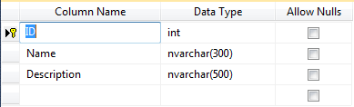

1. ApplicationUsers: contains all System Users who can access the Main portal of the Application.

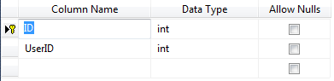

1. AppType: contains lookup data of user types.

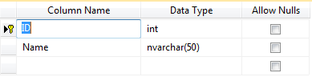

1. Carriers: carries all carriers from who we receive CDRs… this table is incremented automatically whenever we receive a CDR from an undefined carrier.

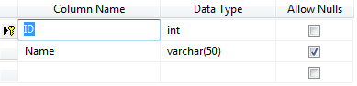

1. CasesLogs: used to log case statuses through the case cycle in case management module.

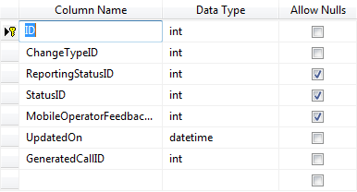

1. ChangeTypes: lookup table for change types that may occur for a given case.

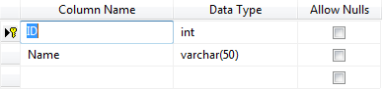

1. Clients: contains lookup table for clients that we provide service in this application, also we specify types of reports that are allowed to be sent through deployed windows services.

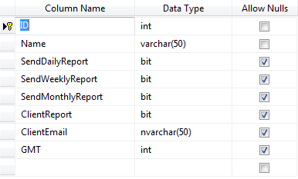

1. EmailCCs: contains cc list to whom we sent reports for given clients and mobile operators.

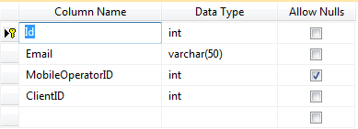

1. Emails: contains log of all Emails sent by the system to clients and mobile operators for tracking purpose.

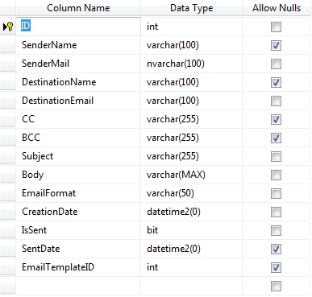

1. EmailTemplates: carries templates for emails that are send to customers

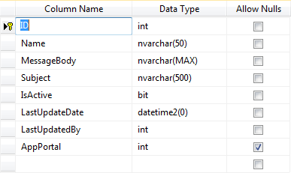

1. EmailTokens: contains characters that are replaced on runtime in email templates... for example we have %link% … this token will contain URL that is sent in the email sent.

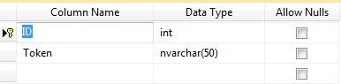

1. GeneratedCalls: carries all generated calls that are collected from generating sources defined in sources table.

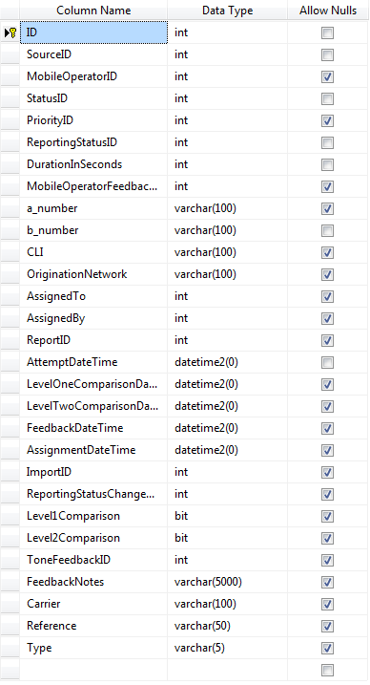

1. GMTs: lookup table for GMTs

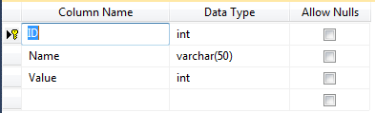

1. Imports: logs all the imports that are done either manually or automatically.

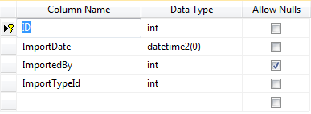

1. ImportTypes: lookup table for import types (Generated or Received)

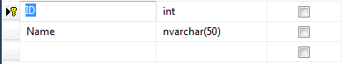

1. LoggedActions: contains log of actions that are done by system users

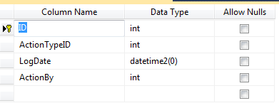

1. MobileOperatorFeedbacks: lookup table for feedback of operators

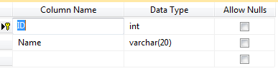

1. MobileOperators: contains mobile operators registered in Fzero.

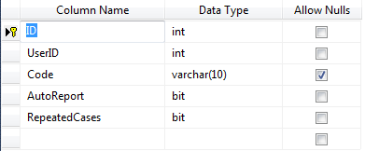

1. OriginationNetworks: carries all the origination networks from which we received calls... Note that this table is automatically updates… i.e. Whenever a new CDR is imported from a new origination network not registered before... the network will be inserted automatically

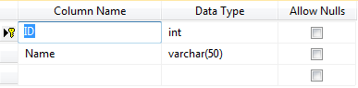

1. Permissions: contains set of permissions that might be granted to system users.

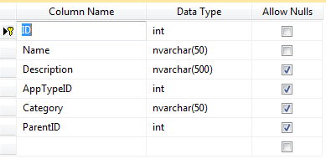

1. PredefinedColumns: lookup table for predefined columns used in mapping CDRs to generated or received calls table.

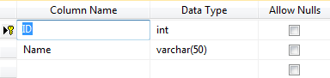

1. PredefinedColumnsforRelatedNumbers: same as above but it is specific for related numbers.

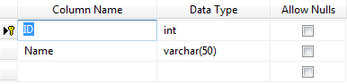

1. Priorities: lookup table for priorities in the suspicion level of cases

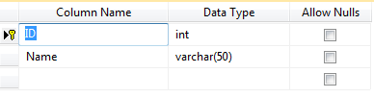

1. RecievedCalls: contains all the received calls that are collected form the sources that are specified in sources table who are receivers

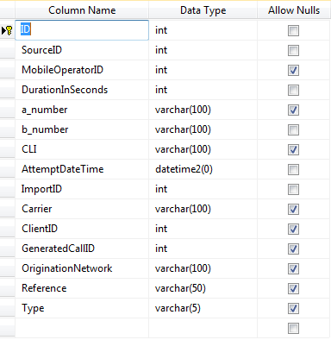

1. RecievedEmails: logs all the emails that where received by Fzero

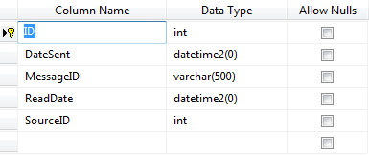

1. RecommendedActions: lookup table for recommended action for cases

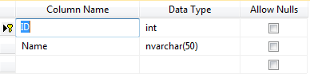

1. RelatedNumberMappings: contains mapping for related numbers… that is used to import related numbers delivered by mobile operators.

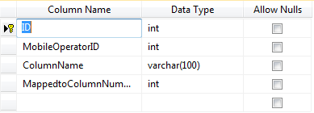

1. RelatedNumbers: contains the related numbers to a given number this was sent as fraud to an operator

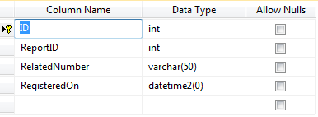

1. ReportingStatuses: lookup of Reporting Statuses for cases immerging in the system.

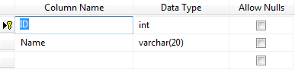

1. Reports: contains reports sent.

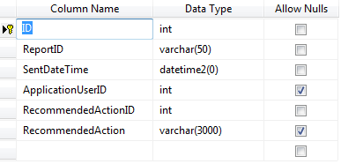

1. SourceKinds: lookup table for source kinds (GSM or SIP)

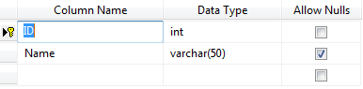

1. SourceMapping: contains mapping of sources in order to know how to read and insert records from sources to Database

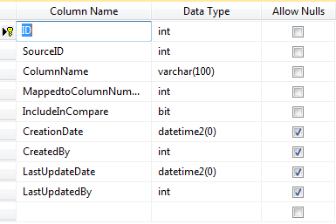

1. Sources: contains all sources that either generate calls or receive or both... with email and GMT of each to solve issue or time difference

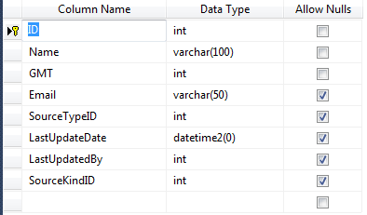

1. SourceTypes: lookup table for Source Types

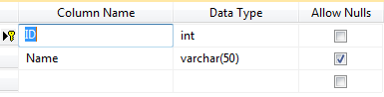

1. Statuses: look up for case statuses

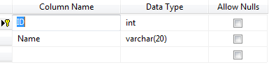

1. SwitchProfiles: contains information or switch that are used in Level two compare

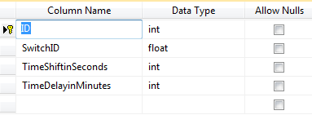

1. SysParameters: configuration parameters table

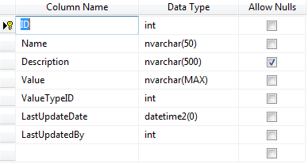

1. ToneFeedback: level two compare related feedback types sent by IGW server

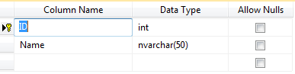

1. UserPermissions: carries permissions of system users

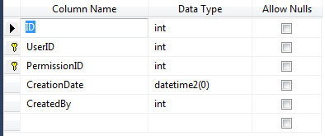

1. Users: used to register all users who can access the application. These users can be System admins or Mobile operators

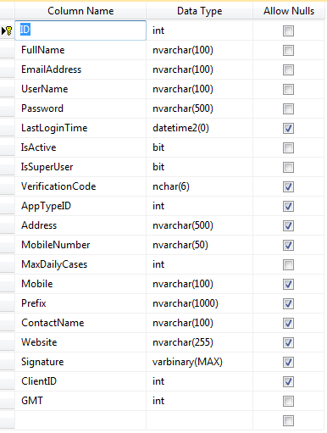

1. ValueTypes: for the configuration system parameters specified above

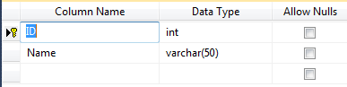

1. WebsiteMenu: contains the menu of the main and clients portals

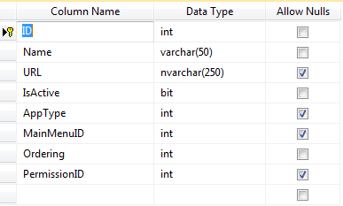

1. **Database Mail Configuration**
2. Mail Accounts:
3. FMS_Account: used to send emails for Clients: ITPC, Zain, and any new client.
4. FMS_Syria_Account: used to send emails for ST only.
5. Profiles:
6. FMS_Profile: related to FMS_Account and specified in sp that queues an email to a given client or mobile operator
7. FMS_Syria_Profile: related to FMS_Syria _Account and specified in sp that queues an email to a given client or mobile operator
8. **Jobs**
9. LevelOneComparison: this job is responsible for comparing generated calls with received calls in order to link them … and find fraud calls... this is done using a complicated mechanism in which a_number, b_number, attemptdatetime and duration and source are needed to find the related calls and to find fraud calls